# Project Name: Smart Weather
# Project Team:
Admin Name and Email ID :
Invitee 1: Only Names
Invitee 2: Only Names
Invitee 3: Only Names
Invitee 4: Only Names
# Sprint Duration: 2 weeks (Minimum or specify the duration if this is customized).

Product Backlog:
As my sprint is completed, all issues from backlog are completed.
I was having 3 epics:
1) Creating Schema for Weather Application
2) Showing Weather Forecast
3) Extra Facilities in the application
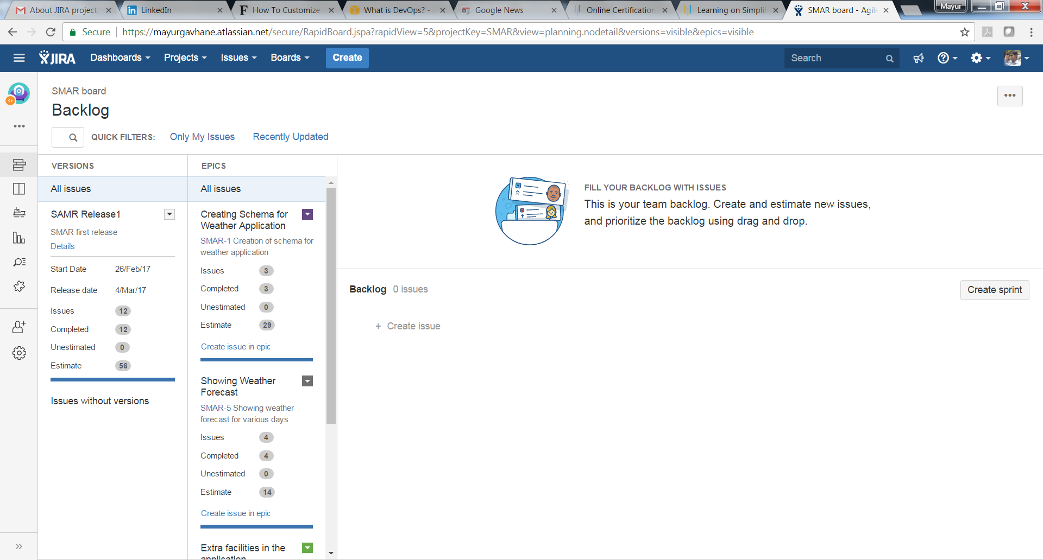
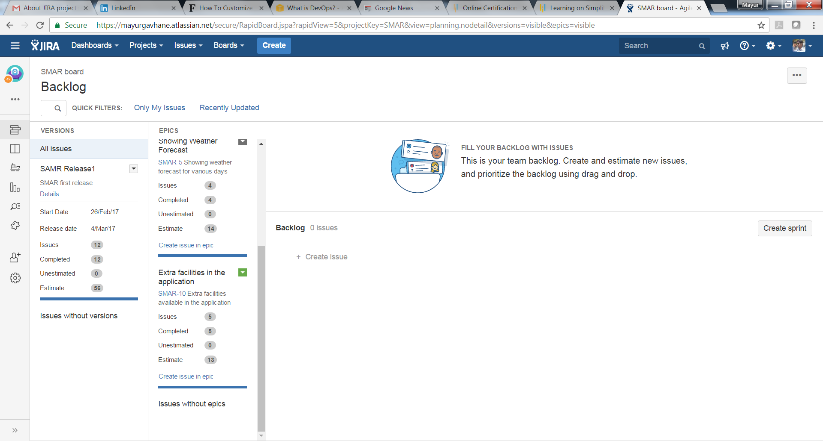
1) Creating Schema for Weather Application
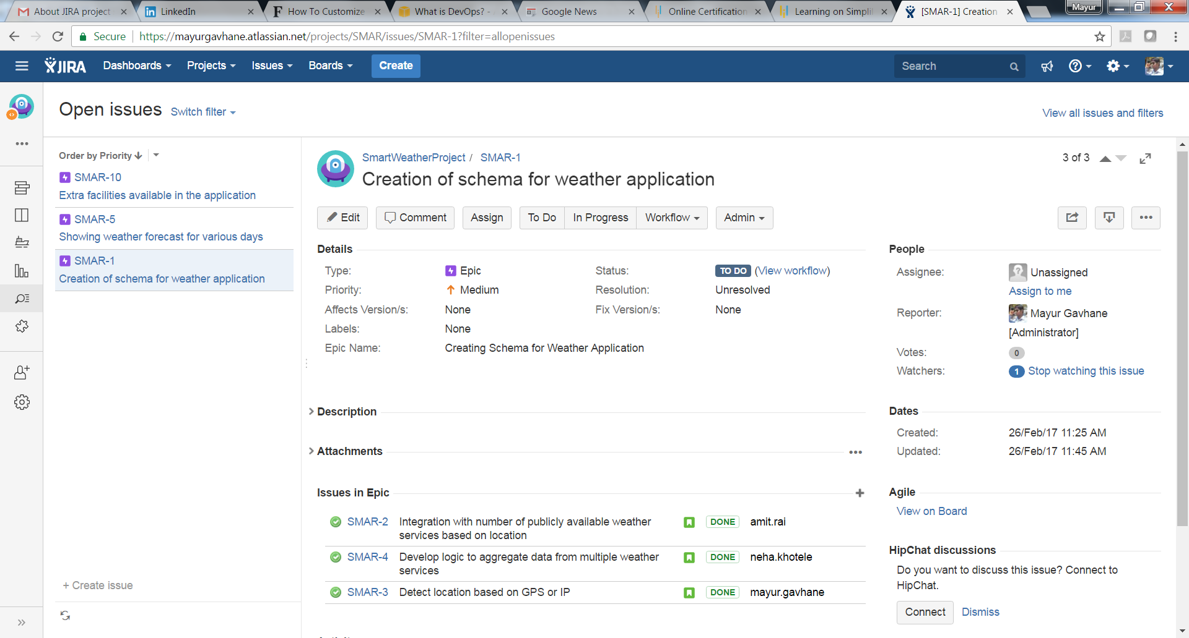
2) Showing Weather Forecast
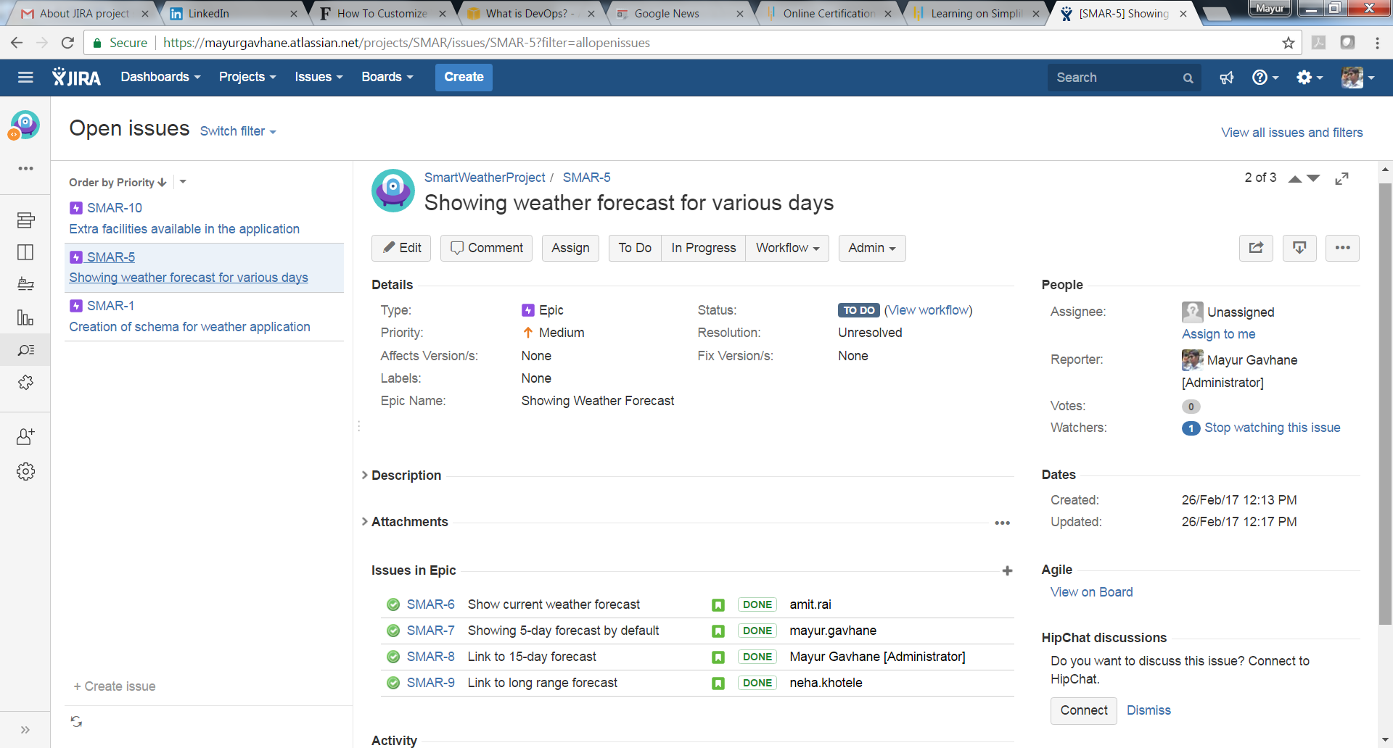
3) Extra Facilities in the application
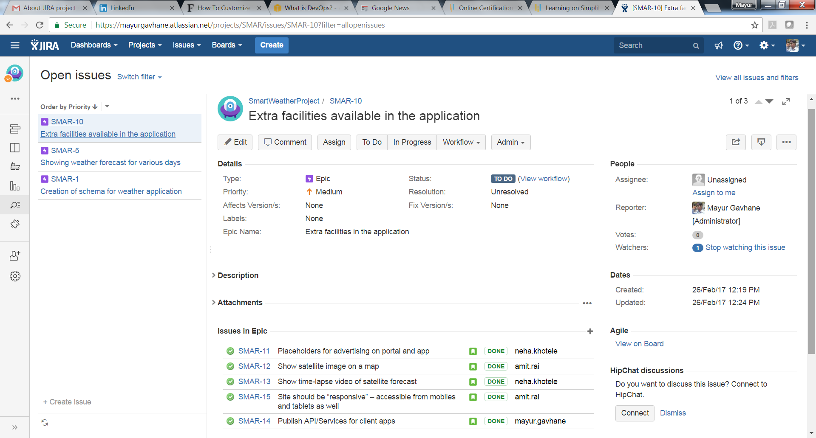
++++++++++++++++++++++++++++++++++++++++++++++++++++++++++++++++++++++++++++

Burndown Chart for the project:
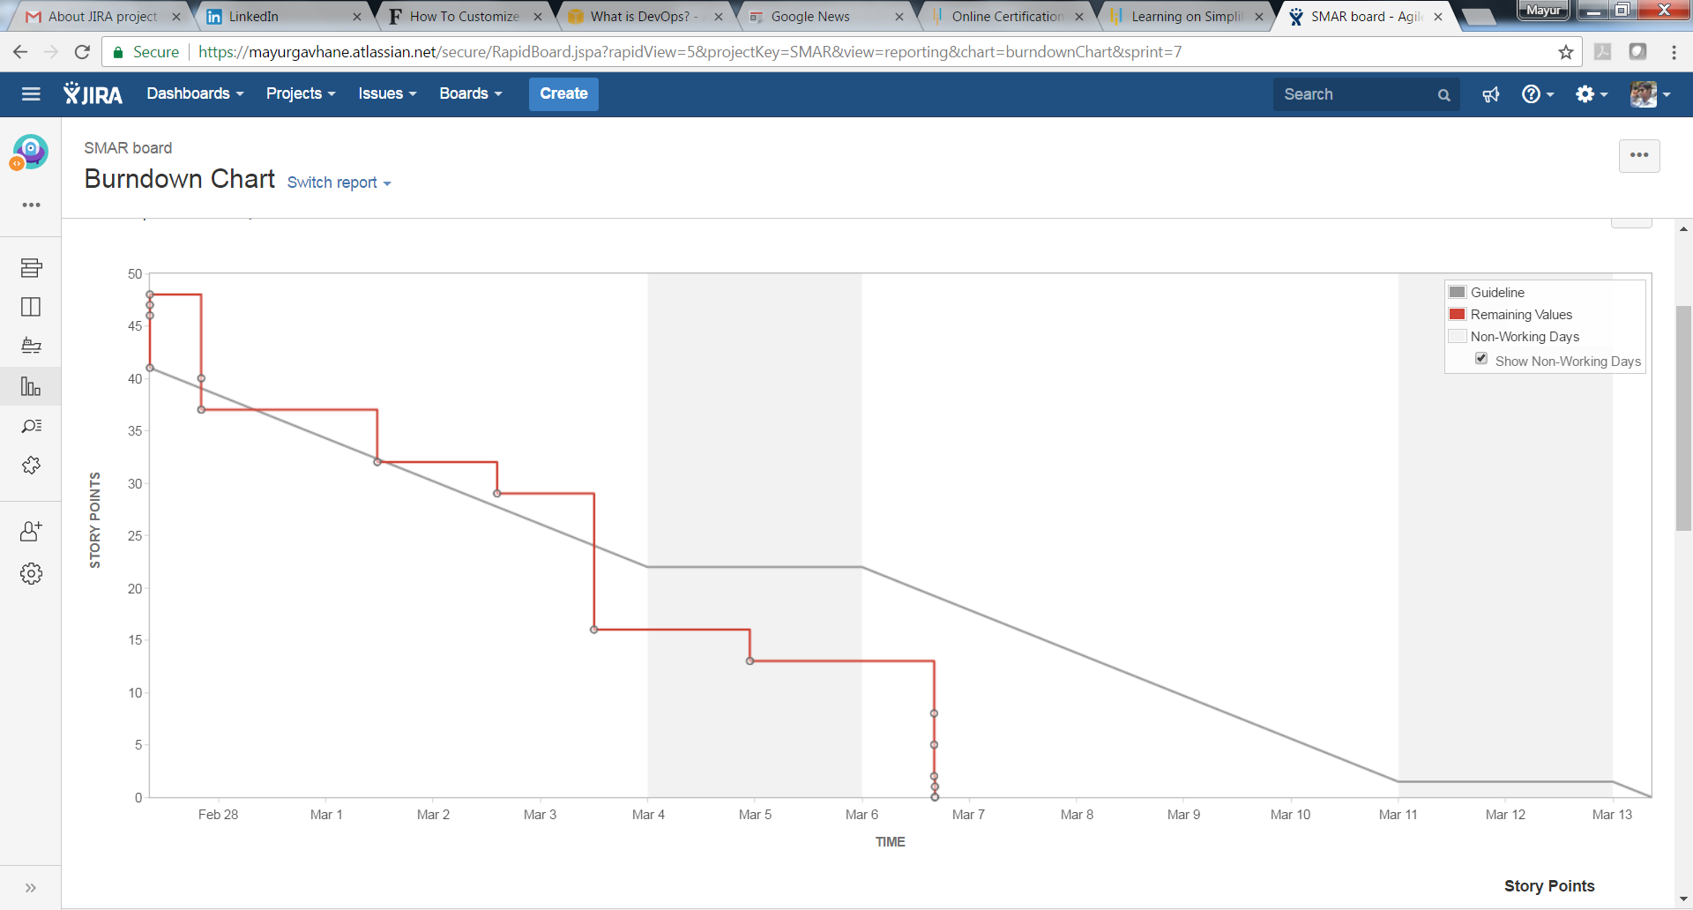
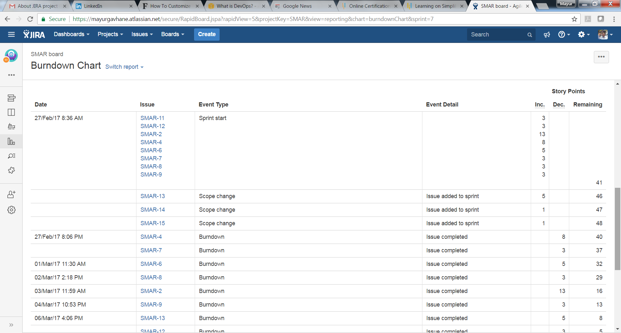
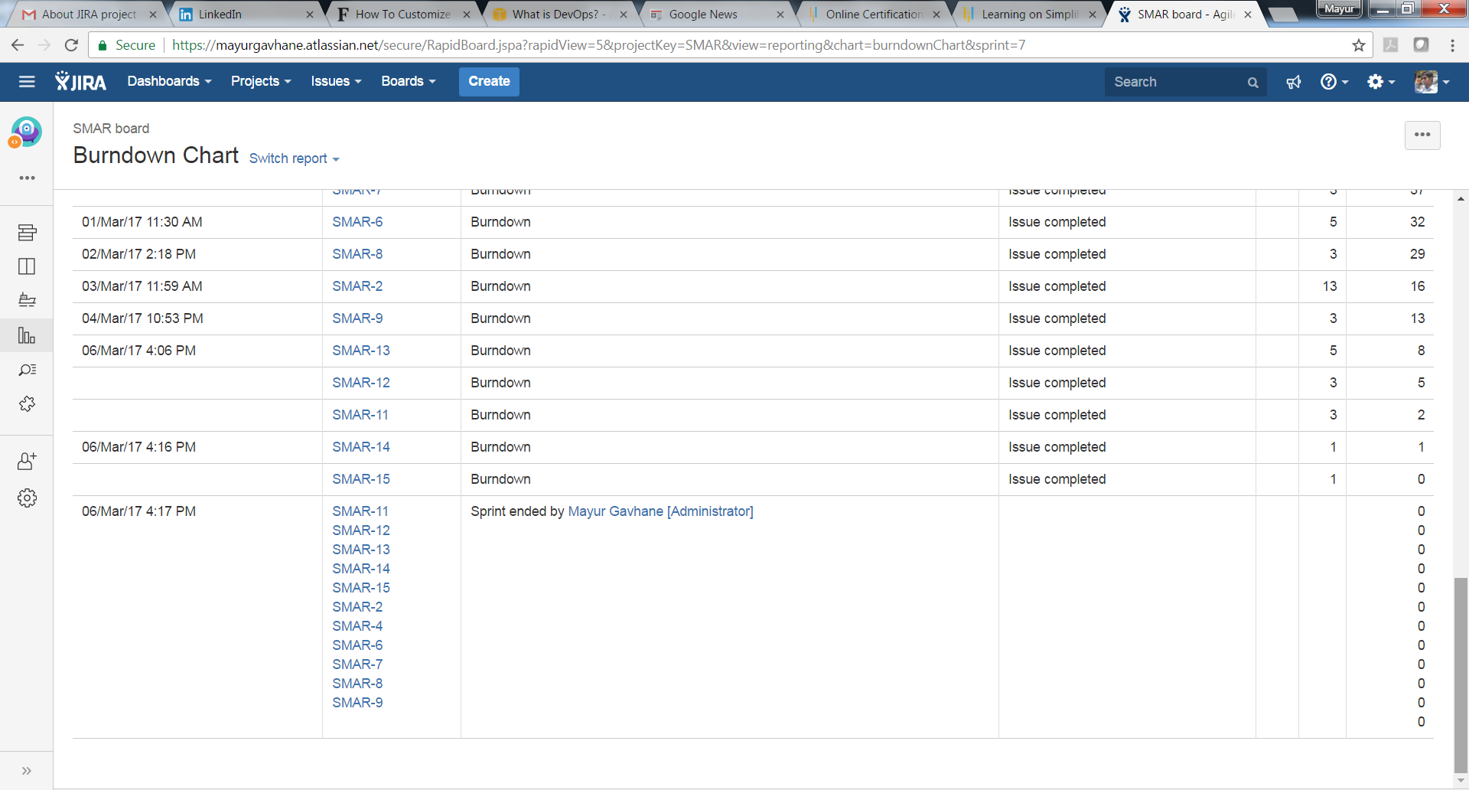
Release Burndown chart for the project:
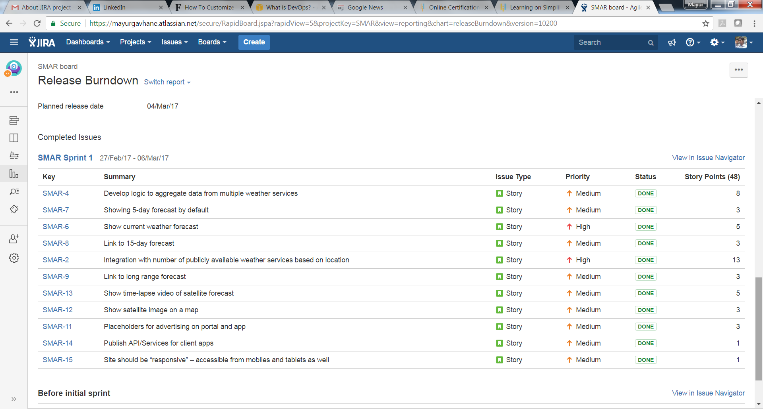
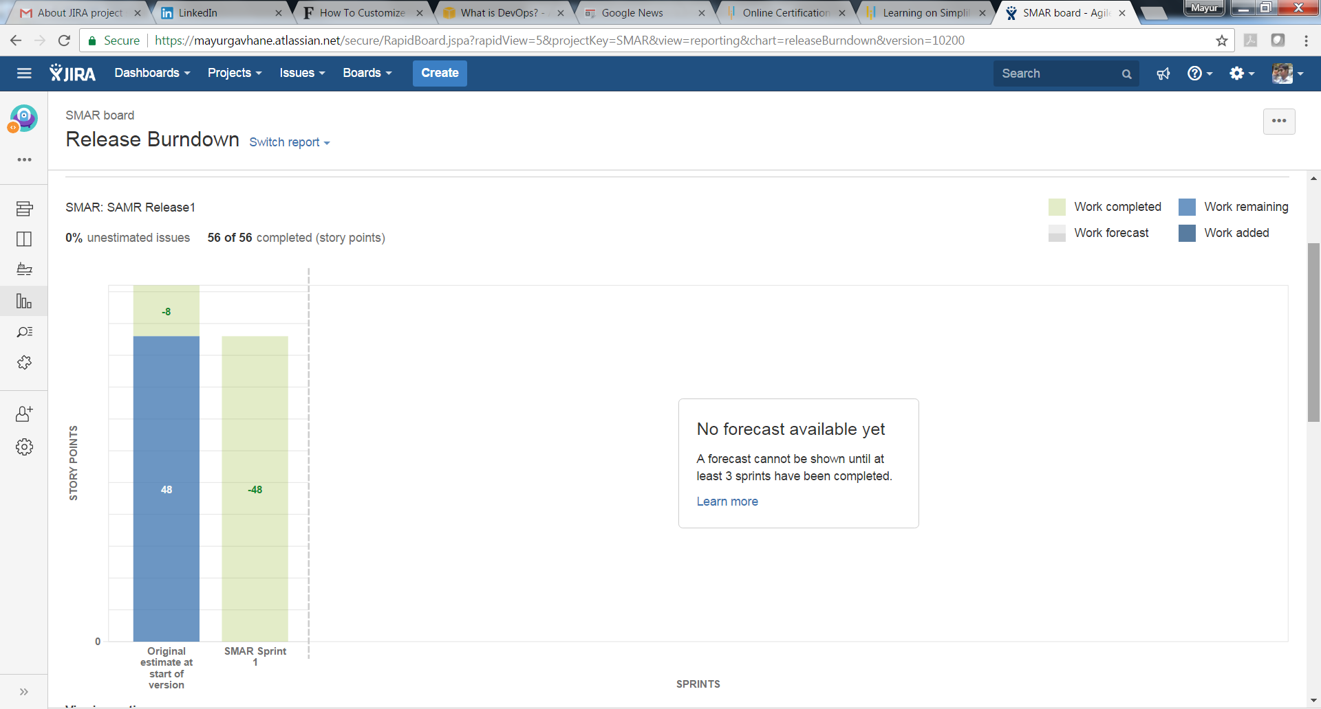

Sprint Report:
